PIZZA SALES

KPI’s
1. Total Revenue:
2. Average Order Value
3. Total Pizzas Sold
4. Total Orders

5. Average Pizzas Per Order

B. Daily Trend for Total Orders
Displays orders for each day of the week.
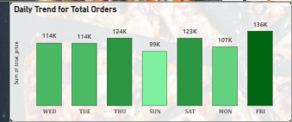
C. Monthly Trend for Orders
Shows how orders vary month-wise.
Peak month: August (72.6K orders)
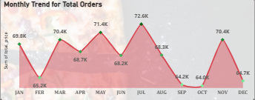
D. % of Sales by Pizza Category
Category contribution:
- Classic – 25.46%
- Supreme – 23.86%
- Veggie – 26.91%
- Chicken – 23.96%

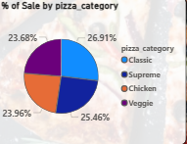
E. % of Sales by Pizza Size
Size contribution:
- Large – 45.89%
- Medium – 30.49%
- Regular – 21.77%
- X-Large & XX-Large – Small %

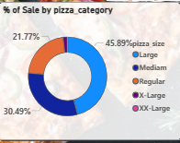
F. Total Pizzas Sold by Pizza Category
Units sold:
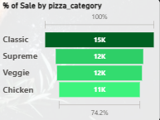
Filters Used
- pizza_category
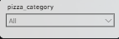
- pizza_size
